

COSHH Assessment Form

This assessment only addresses the risk of harm to health from the substances listed. Additional risk assessments may be required to control the risk from other hazards associated with this work/the procedures used.
Assessor M. Oxley |  | Works Manager
Assessment Date 24/5/16 |  | Dates reviewed 5/17
 |  | 27/6/18 MO
HAZARDS IDENTIFIED:
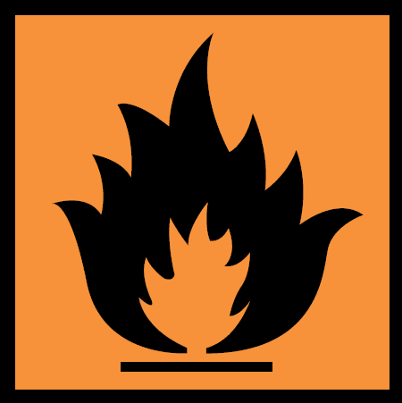
See attached MSDS for full list.
Substance  ACETONE. | Hazardous Properties:  Acetone |  |  |  | Quantity  5ltr drums
 | See MSDS for full list
Eliminating the need to use hazardous substances, consider is it possible to avoid the need to use hazardous substances. | No.
Additional information
Liquid. Clear
Explosive limit lower 2.5 Upper 14.3
First Aid Measures
- In all cases of doubt, or if symptoms persist, seek medical attention. Never give anything by mouth to an unconscious person. If unconscious, place in recovery position and seek medical advice
- Eye contact: Remove contact lenses, Rinse immediately with plenty of water, also under the eyelids, for at least 10 minutes. Seek medical treatment by eye specialist.
- Inhalation: Move to fresh air in case in case of accidental inhalation of vapours. Seek medical treatment immediately
- Skin contact Remove contaminated clothing, Wash off with soap and plenty of water. Consult a doctor if skin irritation persists
- Ingestion: Do not induce vomiting. Summon a doctor immediately. Have this assessment ready to hand to emergency services.

What will the chemical be used for? Cleaning
Who may be exposed? Applicators and those in close vicinity.

EXPOSURE control PPE:
EXPOSURE LIMIT VALUES.
Long term exposure limit 8 hour TWA: WEL 500ppm
Short-term exposure limit 15 mins WEL 1500ppm
Provide adequate ventilation. Forced air.
Wear LEP to avoid splashes.
Wear suitable chemical resistant gloves.
Anti-static overalls to be worn or disposable coveralls.
Wash hands, forearms and face after handling chemicals.
H225. Flam liquid
H319. Eye Irrit.
H317. Skin Sens.
H336. May cause drowsiness or dizziness
P210. Keep away from heat and ignition sources
P261. Avoid breathing vapour/spray
P304 + P340 if inhaled, remove person to fresh air and keep comfortable for breathing.
P305 + P351 + P338 if in eyes rinse with plenty of water
P501. Dispose of contents/container in accordance with national regulations

1. Fire fighting  Firefighting make sure you have a fire extinguisher ready prior to use. Use foam, CO2 or dry chemical.  DO NOT WATER JET  Make sure you spill kit available prior to opening, open only in a well vented area. | 2. Access control (con space).  Stand by man required if area is confined space  Maximum 110v electric tools and lighting.  EX lighting preferred. Type VL51-IP66&67  EEx d IIB T6 ta 55’C  EEx d IIB T5 ta 65’C
3. Special procedures  Do not leave in any confined space. Always use gas detection system.  Air mover to be used at all times on entering vessel. | 4. Approved PPE  Coveralls, boots, helmet and gloves.
For any accidental release.
Ensure adequate ventilation and use appropriate PPE, remove all sources of ignition. Soak up all spillages with inert absorbent material. (E.g. silica gel). Keep area clear of other personnel. Do not allow products to enter sewer or waterways. Inform site contact immediately of any spillages.
Unused material to be taken from site and disposed of by YRL.
TRAINING REQUIREMENTS
Confined space and BA trained
CCNSG safety passport.
HANDLING AND STORAGE REQUIREMENTS
Keep tins tightly closed, only open in good ventilation, use air moves if confined (vapours are heavier than air so ensure that no electrical equipment or any other sources of ignition are on the ground. Keep away from any heat of ignition sources. Keep away from any food, drink, waterways or life stock.

ASSESSMENT OF RISK USING CONTROLS DETAILED ABOVE
Always read risk assessment for job-in-hand, always read safety Date Sheets prior to use. Employees and managers to read and sign this form prior to use.

