

COSHH Assessment Form

This assessment only addresses the risk of harm to health from the substances listed. Additional risk assessments may be required to control the risk from other hazards associated with this work/the procedures used.
Assessor Paul Holroyd |  | Employer/Supervisor
Assessment Date 14-3-18 |  | Dates reviewed 14-3-16. 4/19. 4/20
HAZARDS IDENTIFIED

This product contains traces of isocyanates. Read and follow risk assessment carefully.
Substance  Tip Top Hardener E40. | Hazardous Properties  Ethyl acetate. Thionophosphoric acid – tris –(p-isocyanatophenyl)  Chlorobenzene |  |  |  | Quantity  0.030 Kg bottles
Eliminating the need to use hazardous substances, consider is it possible to avoid the need to use hazardous substances. | No alternative available.  Hardener for BC3004 |  |  |  | 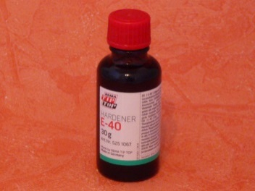
Additional information
Yellowish liquid. Odour, Ester-like
Explosive limit, lower 2.2 Vol%. Upper 11.5 Vol%
Emergency Procedures
- Eye contact: Rinse immediately with plenty of water, also under the eyelids, for at least 15 minutes. Seek medical treatment by eye specialist.
- Inhalation: Move to fresh air in case in case of accidental inhalation of vapours. Seek medical treatment immediately
- Skin contact Wash off with soap and plenty of water. Consult a doctor if skin irritation persists
- Ingestion: Do not induce vomiting. Summon a doctor immediately. Induce vomiting only upon the advice of a physician

What will the chemical be used for? Adhesive used for cold bonding rubber
Who may be exposed? Rubber liners

METHODS OF PREVENTION OR CONTROL OF EXPOSURE
Mix in well ventilated area.
Use half mask with A2 filters fitted.
Wear Chemical resistant gloves (Nitrile).
When entering confined space using Breathing apparatus (larger repairs or full relines). Air mover/ extractor must be used to control exposure to vapours. Air mover must have a flexible hose so vapours are released in to a safe area. (Outside building if possible).
Once solution is applied, a minimum of 30 minutes must be left before re-entry to vessel.
Before re-entering the vessel a gas test must be carried out by Gas tester to ensure area is safe to enter.
Gas test prior to re-entry;
Substances to be gas tested Gastec Tubes WEL 25% value gas test limit
Cyclohexane Hexane 102L* 100 ppm 25ppm
Ethyl Acetate Ethyl Acetate 141L* 200ppm 50ppm
* 102L tubes vocab 37104610
* 141L tubes vocab 37LVO012 (on LVO system therefore need to be pre-ordered)
For smaller repairs, (using ori nasal mask/half mask). Personal gas monitors will be worn to control exposure (BW GasAlert Max XTII).
Air mover/ extractor must be used at all times. Air mover must have a flexible hose so vapours are released in to a safe area. (Outside building if possible).
Once solution is applied, a minimum of 30 minutes must be left before re-entry to vessel.
Change filters after every 15 minutes use.
H225 – Highly flammable.
H336 – may cause drowsiness or dizziness
For full list of statements see MSDS section 2

1. Engineering controls required  Firefighting make sure you have a fire extinguisher ready prior to use. Use foam, CO2 or dry chemical. Make sure you spill kit available prior to opening, open only in a well vented area.  Do not mix solutions in confined space. Only mix in well ventilated area. | 2. Access control  Stand by man required if area is confined space  Maximum 110v tools and lighting.  EX lighting preferred. Type VL51-IP66&67  EEx d IIB T6 ta 55’C  EEx d IIB T5 ta 65’C
3. Special procedures  Do not leave bottles of hardener in any confined space.  Always use gas detection system.  Personal Gas monitor: BW GasAlert Max XTII | 4. Approved PPE  Wear protective clothing, eye protection and gloves.  Half mask with filter SR218 A2 (as advised).  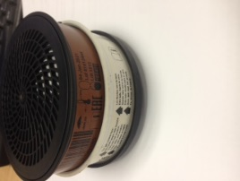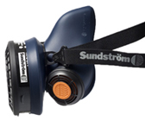
Disposal Procedures
For any accidental release. Ensure adequate ventilation and use appropriate PPE, remove all sources of ignition. Soak up all spillages with inert absorbent material. (E.g. silica gel). Keep area clear of other personnel. Do not allow products to enter sewer or waterways. Inform site contact immediately of any spillages.
Unused material to be taken from site and disposed of by YRL.
TRAINING REQUIREMENTS
Confined space and BA Training
CCNSG safety passport.
HANDLING AND STORAGE REQUIREMENTS
Keep tins tightly closed, only open in good ventilation, use air moves if confined (vapours are heavier than air so ensure that no electrical equipment or any other sources of ignition are on the ground. Keep away from any heat of ignition sources. Keep away from any food, drink, waterways or life stock.

ASSESSMENT OF RISK USING CONTROLS DETAILED ABOVE
Always read risk assessment for job-in-hand, always read safety Date Sheets prior to use. Employees and managers to read and sign this form prior to use.

