

COSHH Assessment Form

This assessment only addresses the risk of harm to health from the substances listed. Additional risk assessments may be required to control the risk from other hazards associated with this work/the procedures used.
Assessor M. Oxley |  | H&S Manager : P. Holroyd
Assessment Date 11/8/16 |  | Dates reviewed 11/8/17
 |  | 27/6/18 MO
HAZARDS IDENTIFIED
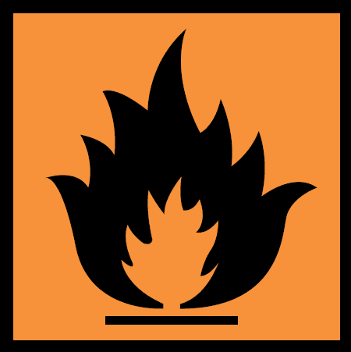
See MSDS for full list.
Substance  Cilbond 12E. | Hazardous Properties  Butanone Selenium, Toluene, Xylene,  Isobutyl Methyl Ketone, solvent naptha. Zinc oxide |  |  |  | Quantity  10ltr.
Eliminating the need to use hazardous substances, consider is it possible to avoid the need to use hazardous substances. | No alternative available. |  |  |  | 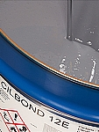
Additional information
Grey Liquid. Aromatic
The information in this document is based on present knowledge
Emergency Procedures
- Eye contact: Rinse immediately with plenty of water, also under the eyelids, for at least 15 minutes. Seek medical treatment by eye specialist.
- Inhalation: Move to fresh air in case in case of accidental inhalation of vapours. Seek medical treatment immediately
- Skin contact: Wash off with soap and plenty of water. Consult a doctor if skin irritation persists
- Ingestion: Do not induce vomiting. Summon a doctor immediately. Induce vomiting only upon the advice of a physician

What will the chemical be used for? Adhesive used for bonding rubber
Who may be exposed? Rubber liners

METHODS OF PREVENTION OR CONTROL OF EXPOSURE
Only use in well ventilated area, if in confined space forced ventilation must be used
Applied to small areas, A half mask fitted with A 2 filters can be used (Areas of less than 1 Mtr Sqr).
Applied to Larger areas an air fed breathing system must be used (areas larger than 1 Sqr Mtr).
FUMES ARE HEAVIER THAN AIR.
Use correct chemical resistant gloves.
Paper coveralls to be worn.
R48/20 – Harmful Danger of serious damage to health by prolonged exposure through inhalation.
R52/53 – Harmful to aquatic organisms, may cause long term adverse effects in aquatic environment
R63 – Possible risk of harm to unborn child
S9 – Keep container in a well ventilated place
S16 – keep away from sources of ignition – no smoking
S26 – In case of contact with eyes, rinse immediately with plenty of water seek medical advice
S36/37 – Wear suitable protective clothing and gloves
S51 – use only in well ventilated areas
S60 – This material and container must be disposed of as hazardous waste.

1. Engineering controls required  Firefighting make sure you have a fire extinguisher ready prior to use. Use foam, CO2 or dry chemical. Make sure you spill kit available prior to opening, open only in a well vented area. | 2. Access control  Stand by man required if area is confined space  Maximum 110v tools and lighting.  EX lighting preferred. Type VL51-IP66&67  EEx d IIB T6 ta 55’C  EEx d IIB T5 ta 65’C
3. Special procedures  Always use gas detection system. | 4. Approved PPE  Wear protective clothing, eye protection and gloves.  Half mask with filter SR218 A2 (as advised).  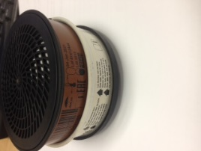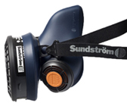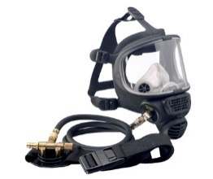
Disposal Procedures
For any accidental release. Ensure adequate ventilation and use appropriate PPE, remove all sources of ignition. Soak up all spillages with inert absorbent material. (E.g. silica gel). Keep area clear of other personnel. Do not allow products to enter sewer or waterways. Inform site contact immediately of any spillages.
Unused material to be taken from site and disposed of by YRL.
TRAINING REQUIREMENTS
Confined space and BA Training
CCNSG safety passport.
HANDLING AND STORAGE REQUIREMENTS
Keep tins tightly closed, only open in good ventilation, use air moves if confined (vapours are heavier than air so ensure that no electrical equipment or any other sources of ignition are on the ground. Keep away from any heat of ignition sources. Keep away from any food, drink, waterways or life stock.

ASSESSMENT OF RISK USING CONTROLS DETAILED ABOVE
Always read risk assessment for job-in-hand, always read safety Date Sheets prior to use. Employees and managers to read and sign this form prior to use.

